OSSP (Operating Systems And Systems Programming) - 25CS2104E
Slip Test-1

SCENARIO / CASE STUDY – 1: Creating a New Process
A Linux developer executes the following program:

</> C
pid = fork();

The program successfully creates a child process.

1A. 5 Marks
Arrange the major components involved in executing the fork() operation in the order in which control passes through them, starting from the user application and ending with the hardware resource. Relate each component to its position in the Linux software stack.

1B. 7 Marks
A student is asked to investigate the execution of fork() using a Linux system-monitoring/tracing tool. Construct an investigation plan that identifies:
- the user-space program involved,
- the system call associated with process creation,
- the transition between User Mode and Kernel Mode,
- the major kernel service involved in creating the process,
- and the information that can be observed to confirm successful process creation.

1C. 3 Marks
A malicious program attempts to create an unlimited number of processes to exhaust system resources. Analyze how Linux process-management and protection mechanisms can restrict or control such behavior.

STEP 1: Open Terminal

Step 2: Create a C file And Enter the code
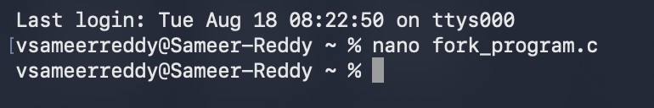

Step 3: Save the file
- PRESS CONTROL + O

PRESS ENTER
- PRESS CONTROL + X

Step 4: Compile

Step 5:Run
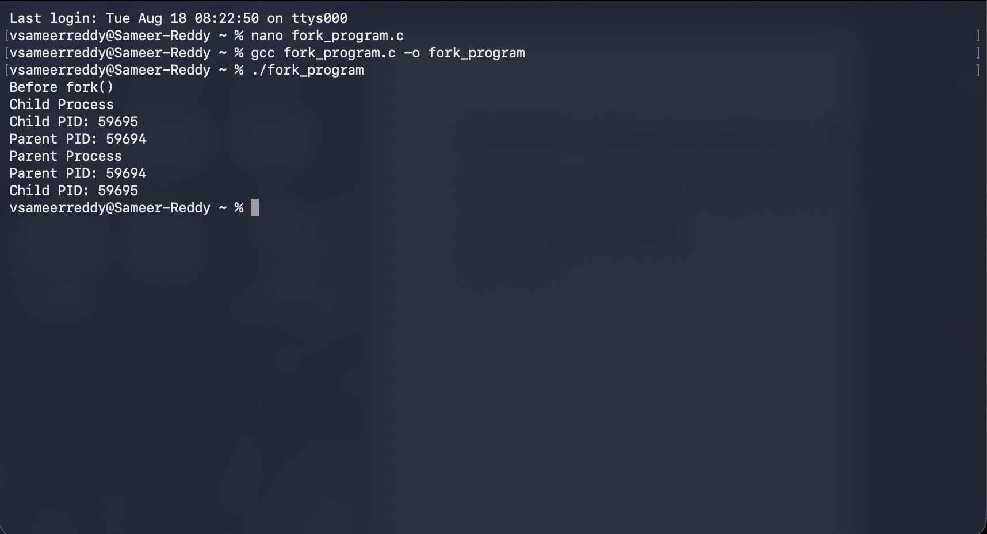

To trace it

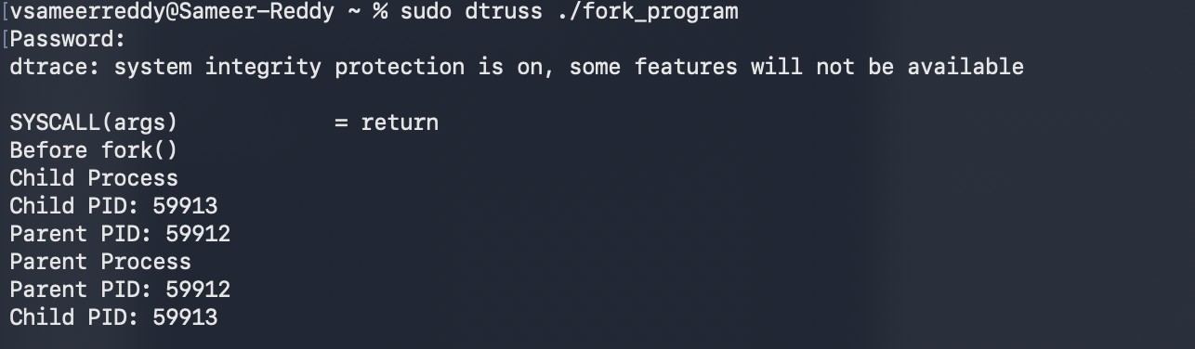

FOR NORMAL EXECUTION
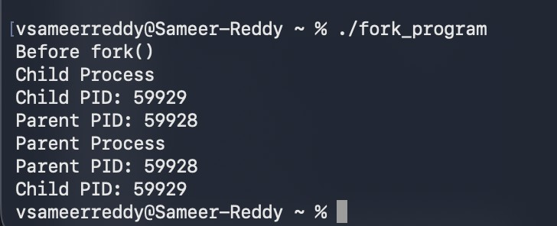

SCENARIO / CASE STUDY – 3: Executing a Linux Command
A user enters the following command in a Linux terminal:

</> Bash
ls -l /home/student
The shell accepts the command and displays the contents of the directory.

3A. 5 Marks
Arrange the major components involved in executing the command in the order through which control passes, starting from the user and shell and ending with the hardware resources. Relate each component to its position in the Linux software stack.

3B. 7 Marks
Construct an investigation plan to study the execution of the ls command. Your plan should identify:
- the user-space program involved,

- the system calls used to access directory information,
- the transition between User Mode and Kernel Mode,
- the relevant Linux kernel services,
- and the role of the file-system layer in producing the output.

3C. 3 Marks
A user tries to execute ls on a directory for which they have no execute/search permission. Analyze how Linux access-control mechanisms affect the result.

